Automated AI-Powered Multi-Platform Social Media Content System
Author: Syed Ali Husnain Shah
Degree/Program: Bachelor in Artificial Intelligence (FAST-NUCES CFD Campus)
Year: 2026

1. Abstract
In today’s fast-paced digital landscape, managing multi-platform social media content is both time-consuming and prone to inconsistency. This project presents a fully automated, AI-driven system for generating, refining, and publishing content across multiple social media platforms (LinkedIn, Facebook, Instagram). The system integrates platform-specific content optimization, generative AI visuals, automated workflow pipelines, and event-aware content adjustments, ensuring brand consistency, marketing effectiveness, and operational efficiency.

2. Objectives
- Automate content creation and publishing across multiple social media platforms.
- Ensure platform-specific optimization (captions, hashtags, tone).
- Integrate AI-generated visuals for products and solutions with brand consistency.
- Enable human-in-the-loop refinement via Slack approval workflows.
- Support event-sensitive content, including religious and patriotic events.
- Provide a scalable, deployable pipeline for real-world use.

3. System Architecture

3.1 High-Level Architecture Diagram
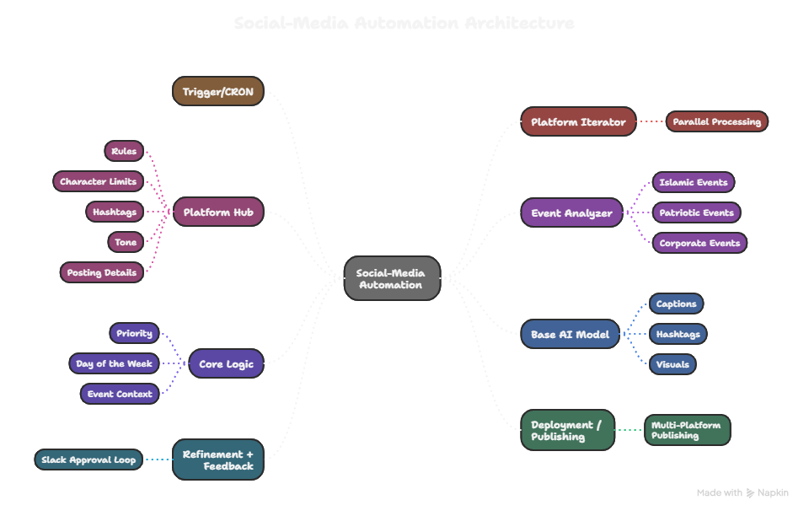

Description:
- Trigger/CRON: The workflow starts automatically based on scheduled timings.
- Platform Iterator: Runs the content generation for multiple platforms in parallel.
- Platform Hub: Central configuration for platform rules, character limits, hashtags, tone, and posting details.
- Event Analyzer: Detects special events (Islamic, patriotic, corporate) and adjusts content tone.
- Core Logic: Determines which product or solution to highlight, based on priority, day of the week, and event context.
- Base AI Model: Generates captions, hashtags, and visuals using AI models.
- Refinement + Feedback: Optional human-in-the-loop for reviewing and refining content.
- Deployment / Publishing: Final content is posted to each social platform automatically.

3.2 Module Overview
Module | Purpose | Key Components | Input | Output
Platform Iterator | Multi-platform execution | n8n workflow | Active platforms | Platform-specific items
Platform Configuration Hub | Single source of truth | JSON config, content rules | Platform details | Rules & specifications
Event Analyzer | Event sensitivity | Hijri calendar API, patriotic event flags | Current date, events | Event Mode (Active/Inactive)
Core Logic Engine | Product & post selection | Deterministic weekday rotation, priority override | weekday, isFriday, isWeekend, postType, priority | Product lock, marketing mode
AI Model | Content & visual generation | LLM & generative AI models | Input data, product lock, event mode | Captions, hashtags, AI visuals
Refinement Workflow | Human approval | Slack integration | Draft content | Approved content
Deployment & Publishing | Automated posting | LinkedIn, Facebook, Instagram nodes | Approved content | Published posts

4. Algorithm & Workflow Details
4.1 Product & Post Selection Algorithm
- Check if product_id is locked:
  - If yes → use provided product.
  - If no → determine product using weekday rotation rules and priority override.
- Determine post type:
  - Product showcase, solution story, or system demonstration.
- Event Awareness:
  - If combinedEvents.length > 0 → enable Event Mode and adjust tone, lighting, and caption.
- Finalize product lock for AI content generation.
4.2 AI Content Generation
- LLM generates:
  - Captions (within platform character limits)
  - Hashtags (optimized per platform)
  - CTA (call-to-action) text
- Generative AI produces ultra-realistic product visuals:
  - Camera and lighting parameters simulate real-world photography
  - Brand colors and logos enforced
- Event-aware adjustments:
  - Colors, lighting, and scene composition respect cultural and religious sensitivities
4.3 Refinement & Human Approval
- Slack integration allows reviewers to:
  - Approve, cancel, or request rework
  - Feedback loop feeds back into AI refinement
- Ensures 100% brand consistency and audience-appropriate tone
4.4 Deployment
- Approved content automatically published:
  - LinkedIn: Organization post node
  - Facebook: Page post node
  - Instagram: Media container + publish node
- Logging & analytics capture publishing status for each platform

5. Deployment & Scalability
- Platform: n8n workflow automation on a server or cloud instance
- Dependencies:
  - Node.js, Python
  - n8n nodes: AI, Slack, social media APIs
  - LLM API (OpenAI or similar)
- Scalability:
  - Parallel platform execution supports multiple accounts and high-volume posting
  - Modular hub allows adding Twitter, TikTok, Pinterest, or other platforms
- CI/CD: Can be connected with GitHub Actions to deploy updated workflows automatically

6. Technical Stack
- Backend: Python & Node.js
- Automation: n8n
- AI Models: GPT-based LLM for captions, Stable Diffusion or similar for visuals
- APIs: LinkedIn, Facebook, Instagram, Slack
- Data Sources: Hijri calendar API, event JSON datasets
- Version Control: GitHub (Repo Link)
- Deployment: Cloud or local server (Linux preferred)

7. System Features Summary
- Brand-safe, deterministic AI content generation
- Multi-platform support with parallel execution
- Event-sensitive content adaptation
- Human-in-the-loop refinement for approval
- Automated deployment & publishing
- Visuals consistent with real-world photography standards

8. Diagrams & Visuals
- Workflow Diagram (shown in 3.1)
- Product Selection Flowchart:
- 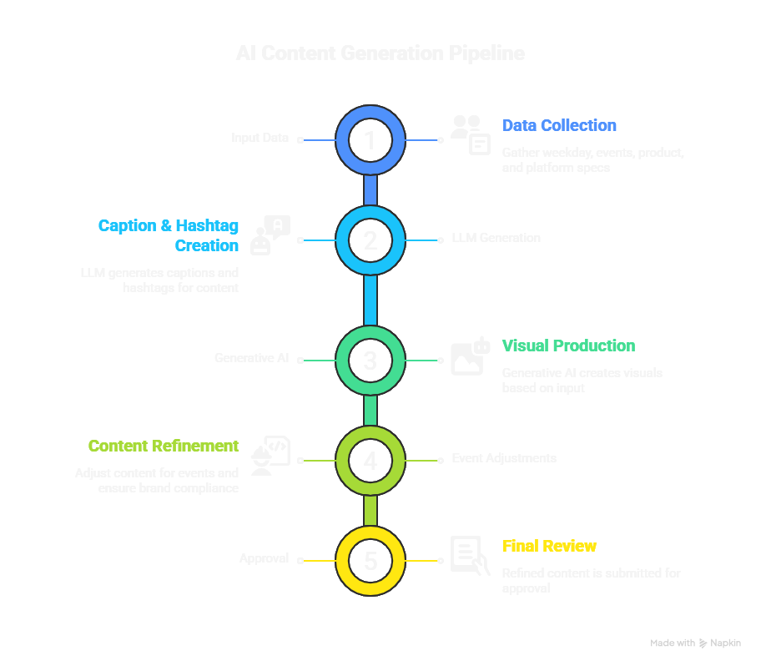

9. Use Cases
- Corporate Social Media Management: Automatically generate professional content for multiple brands.
- Marketing Agencies: Reduce content creation workload while ensuring quality and compliance.
- Event Promotions: Post timely, culturally relevant content during holidays and national events.
- E-commerce Platforms: Showcase products with visually appealing AI-generated imagery.

10. Conclusion
This project demonstrates how AI-driven automation can revolutionize social media content workflows. By combining deterministic logic, event-aware adjustments, and high-quality visual generation, it ensures professional, engaging, and brand-consistent content at scale.
It provides a production-ready solution for organizations seeking efficiency, scalability, and consistency in their digital marketing strategy.

11. References
- n8n Documentation: https://docs.n8n.io/
- OpenAI GPT API Documentation: https://platform.openai.com/docs/
- Stable Diffusion: https://stability.ai/

